- Eight puzzle problem
Instructions:
- Read eightpuzzle.hpp carefully. Especially, you should read the definition of structure EightPuzzleState, AStarSearchFor8Puzzle() and runMoves(); Notice the definition of moving direction.
- Review A* algorithm in Lec2. The core idea of A* algorithm is to explore (expand) node with smallest g+h value. We need a prior queue, named “openlist” to store nodes that will be explored. A nice property of prior queue is that, elements inside of in are ordered. For example, if openlist is C++ priority_queue object, the function openlist.top() will return the the element with smallest g+h value in A* algorithm if openlist is defined properly.
- Here is a pseudocode
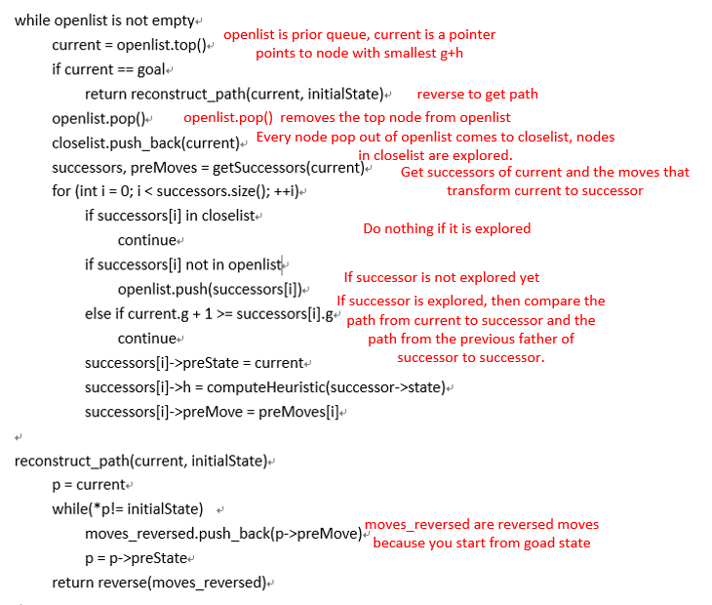
In above pseudocode, openlist and closelist are defined as what I show you in function AStarSearchFor8Puzzle(), i.e.
priority_queue<EightPuzzleState*, vector<EightPuzzleState*>, cmpLarge> openlist;
vector<EightPuzzleState*> closelist;
Note that they store the pointers of EightPuzzleState objects.
- You need to fill in function AStarSearchFor8Puzzle() and write some other function like checking whether an EightPuzzleState object is in openlist. After you finish these, run main_eightpuzzle.cpp, you will get something like the following:
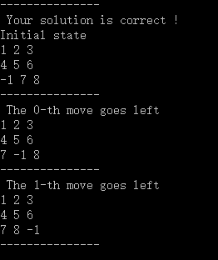
Start from simple examples to debug, you can read line 8 of main_eightpuzzle.cpp to see how to make it.
- Here is a reference for priority_queue in C++
http://www.cnblogs.com/chinazhangjie/archive/2010/10/31/1865653.html
Here is a reference for vector
http://www.cnblogs.com/wang7/archive/2012/04/27/2474138.html
- Zip your eightpuzzle.cpp eightpuzzle.hpp to XXXXXXXX_project_1_eightpuzzle.zip, XXXXXXX stands for your student ID. Please follow this name rule so I can test your code.
- The framework is done in limited time, if your find any bugs, please inform me.
- Tic tac toe
Instructions:
- Read tic_tac_toe.hpp carefully. Be familiar with the definition of struct TicTacToeState, struct Action and function miniMaxSearchForTicTacToe();
To limit searching space, you can use depth limited strategy. The recommend depth is 3, i.e., nodes at depth of 3 are considered as leaf node.
There are some other assumptions:
1. The computer player use circle and you use cross.
2. The computer player is MAX user and you are MIN user.
3. You moves first.
- You need to follow the pseudocode of Minimax Algorithm in Lecture slids
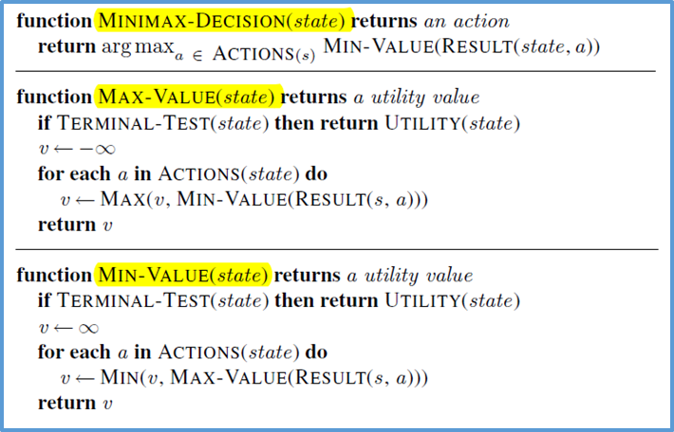
The main concerns of you is to design a heuristic function to replace UTILITY() in above code, and check wether a state is a terminal state(the TERMINAL-TEST fucntion). In TERMINAL-TEST(), you need to consider some boundary conditions, such as all the spaces are occupied.
- You may need to write some other function to support your miniMaxSearchForTicTacToe(). Consider to use TicTacToeState and Action.
You may not revise the code of class GameJudge.
- After you finish miniMaxSearchForTicTacToe(), run main_tic_tac_toe.cpp. You can get an interactive game. Try it and see if it has some intelligence.
- Zip your tic_tac_toe.cpp tic_tac_toe.hpp to XXXXXXXX_project_1_tictactoe.zip, XXXXXXX stands for your student ID. Please follow this name rule so I can test your code.
- If you encounter any bug, please inform me.

